Introduction:
SOUND/SOLAR power generation is one of the most important renewable energy sources that have been gaining increased attention in recent years. Solar energy is plentiful; it has the greatest availability compared to other energy sources. The amount of energy supplied to the earth in one day by the sun is sufficient to power the total energy needs of the earth for one year. Solar energy is clean and free of emissions, since it does not produce pollutants or by-products harmful to nature. The conversion of sound energy into electrical energy has many application fields. Recently, research and development of low cost flat-panel piezo panels, thin-film devices, concentrator systems, and many innovative concepts have increased. In the near future, the costs of small sound-power modular units and sound-power plants will be economically feasible for large-scale production and use of sound energy.

In this paper we have presented the sound panel’s operation. The foremost way to increase the efficiency of a sound panel is to use a Maximum Power point Tracker (MPPT), a power electronic device that significantly increases the system efficiency. By using it the system operates at the Maximum Power Point (MPP) and produces its maximum power output. Thus, an MPPT maximizes the array efficiency, thereby reducing the overall system cost. In addition, we attempt to design the MPPT by using the algorithm of a selected MPPT method which is “Perturb and Observe” and implement it by using a DC- DC Converter. We have found various types of DC-DC converter. Among them we have selected the most suitable converter which is “BOOST” converter, for our design.

sound generation systems generally use a microcontroller based charge controller connected to a battery and the load. A charge controller is used to maintain the proper charging voltage on the batteries. As the input voltage from the solar array, the charge controller regulates the charge to the batteries preventing any overcharging. So a good, solid and reliable sound charge controller is a key component of any sound battery charging system to achieve systems maximum efficiency. Whereas microcontroller based designs are able to provide more intelligent control and thus increases the efficiency of the system.

Relevance:
In this proposed system Maximum power point tracker battery charger is proposed for extracting maximum power from a photovoltaic panel to charge the battery. The output power of the sound system continuously varies with change in irradiance and temperature. It is very important to improve the efficiency of charger. There are number of maximum power point tracking (MPPT) methods available to operate the PV system at maximum power point. The proposed system have used Perturb & Observe (P&O) MPPT algorithm for the design and implementation. When irradiance and temperature are constant or slowly varying, the P&O method tracks MPP steadily and calculate the operating point at which the battery is capable of producing maximum power. In this method, the controller provides the PWM signal to adjust the voltage, adjustment is done by Buck converter and measures power, if the power increases, further adjustments in that direction are tried until power no longer increases.

Literature Review:
- Huynh D.C & et. all. Maximum power point tracking of solar photovoltaic panels using advanced perturbation and observation algorithm. IEEE June 2013.
This paper proposes an advanced perturbation and observation (P&O) algorithm for tracking the maximum power point (MPP) of a solar PV panel. Solar PV cells have a non-linear V-I characteristic with a distinct MPP which depends on environmental factors such as temperature and irradiation. In order to continuously harvest maximum power from the solar PV panel, it always has to be operated at its MPP. The proposed P&O algorithm can reduce the main drawbacks commonly related to the P&O algorithm. This is achieved with determining the short-circuit current before each perturbation and observation stage. The obtained simulation results are compared with MPPs achieved using the conventional P&O algorithm under various atmospheric conditions. The results show that the advanced P&O algorithm is better than the conventional P&O algorithms for tracking MPPs of solar PV panels. Additionally, it is simple and can be easily implemented in digital signal processor (DSP).[1]

Grzesaik. W. MPPT Solar Charge Controller for High Voltage Thin Film PV Modules. IEEE May 2006.

The work deals with a PV battery charge regulator assigned for advanced CdTe modules of output voltage much higher than the popular values of the order 12 or 24 V nominally. As at the same time most of the nominal PV autonomous installation voltages generally remain on the 12 or 24 V level because of convenience, technical tradition and battery features- this high DC module's voltage has to be transformed to a proper lower value by means of DC/DC inverter of possibly high efficiency. A new own developed 60/12 V charge controller solution is presented. This charge controller is equipped with a "step-down" inverter version furnished with modern MPP tracking technique. The choice of MPPT algorithm and its realization by means of microprocessor are explained and discussed as well as final test and measurement results. Very satisfactory exploitation results permit to estimate the solution as a valuable one for the new high voltage modules' market.[2]

Petchjatuporn. P and et. all. A Solar-powered Battery Charger with Neural Network Maximum Power Point Tracking Implemented on a Low-Cost PIC-microcontroller. IEEE Nov 2005.

This paper presents the development of a maximum power point tracking algorithm using an artificial neural network for a solar power system. By applying a three layers neural network and some simple activation functions, the maximum power point of a solar array can be efficiently tracked. The tracking algorithm integrated with a solar-powered battery charging system has been successfully implemented on a low-cost PIC16F876 RISC-microcontroller without external sensor unit requirement. The experimental results with a commercial solar array show that the proposed algorithm outperforms the conventional controller in terms of tracking speed and mitigation of fluctuation output power in steady state operation. The overall system efficiency is well above 90%.[3]

Longxi. Chang & et. all. A fully integrated solar charger controller with input MPPT regulation protection for 10V to 28V solar-powered panel. IEEE June 2013.

A fully integrated solar charger controller is presented in this paper. The charger has wide input voltage range about 10V to 28V for the solar-powered panel. The input loop regulation is used here as the MPPT protection. This charger also provides different kinds of battery voltages about 4V to 12V. The controller system uses just one error amplifier and no external compensation components is needed. Besides, this controller has 600 kHz PWM modulation and offers the over-current/overvoltage protection. Other components like bandgap, reference generator, saw-tooth generator, register controller and driver circuits are all implemented in this circuit. This chip is fabricated in a 0.4-μm 5V/40V 2P4M process. The power consumption of this full-integrated solar charger controller IC is about 10mA.[4]
Maximum Power Point Tracking
As previously stated, other methods need to be employed to monitor and improve efficiency of solar panels. The most popular method is Maximum Power Point Tracking, or MPPT. MPPT is measuring the power of the solar panel at given intervals and making sure it is always at its maximum power. A measurement is taken from the solar panel and the power is calculated. After a specified interval, another measurement is taken. These two measurements are compared, and adjustments are made to the solar panel to ensure that the most recent measurement will lead to the maximum power.
MPPT is not a new technology. Some companies have been designing solar trackers for years. Most solar trackers move with regard to the angle of the sun, and do not constantly calculate power. Linak, for example, has two different types of solar tracking systems that both use integrated control actuators. The solar panels can either move 180 degrees (single axis) or can tilt in all different angles using dual access [23]. First Solar and Solar Flexrack have similar trackers that follow the movement of the sun throughout the day [20] [31]. These trackers are controlled by MPPT controllers. Controllers such as the MPPT Tracer Solar Charge Controller are installed and read a solar panel. Based on the information read, all solar panels are adjusted to follow the sun’s path [22].
Though there are some MPPTs already on the market, our team has decided to make our own MPPT using a converter and microcontroller. The following paper illustrates our thought process during the design of our MPPT, along with results of our working product.

Proposed work:

a. Scope: The proposed system is to present a novel cost effective and efficient microcontroller based MPPT system for sound energy generation system to ensure the maximum power point operation at all changing Environmental condition. The P&O MPPT algorithm is used to control the maximum transfer power from a sound with piezo crystal panel. This algorithm is executed by an pic microcontroller using the piezo voltage and current data to control the duty cycle of a pulse width modulation signal applied to a DC/DC converter.

b. Methodology: Block diagram for tracker unit

MPPT controller

Energy storage
Battery
Piezo sound/Dc-Dc convertor

Vi measurement

Inverter

Proposed work:
1] MCU:
The MPPT control circuit is implemented in a microcontroller, that has 8bits analog-to-digital (A/D) converters and two four PWM mode signals. The boost converter is controlled by the microcontroller. It read the voltage and current of the solar panels through the A/D port of controller and calculates the output power. It also calculate power by reading the voltage and current of battery side in same way and send corresponding control signal to the boost converter and control the duty cycle of the converter by PWM signal through controller to accordingly increase, decrease or turn off the DC to DC converter. The pic is a perfect combination of performance, features, and low power consumption for this application. The control circuit compares the piezo sound output power before

and after a change in the duty ratio of the DC/DC converter control signal. It is expected that the MPP presents a constant oscillation inherent to the algorithm.
2] DC-DC convertor:-
There are several topologies available for DC-DC converter. Among them buck converter is in an increasingly popular topology, particularly in battery powered applications, as level of the output voltage can be changed with respect to input voltage. The commonly used a converter in PV systems is a DC/DC power converter. It ensures, through a control action, the transfer of the maximum of electrical power to the load. The structure of the converter is determined according to the load to be supplied. In this article we focus on the step-up DC/DC converter (Boost converter). MPPT uses the same converter for a different purpose, such as regulating the input voltage at the Maximum power point and providing load matching for the maximum power transfer.
3] Mppt:
A typical solar panel converts only 30 to 40 percent of the incident solar irradiation into electrical energy. Maximum power point tracking technique is used to improve the efficiency of the solar panel. According to Maximum Power Transfer technique, the output power of a circuit is maximum when the source impedance matches with the load impedance. In the source side a buck converter is connected to a solar panel in order to enhance the output voltage. By changing the duty cycle of the buck converter appropriately by PWM signal the source impedance is matched with that of the load impedance. There are various MPPT techniques are proposed. Among those methods, the perturb and observe (P&O) and incremental conductance (INC) methods are widely used although they have some problems such as the oscillation around MPP and confusion by rapidly changing atmospheric conditions.
In this proposed system perturb and observe MPPT algorithm is used. In this method the controller adjusts the voltage by a small amount from the array and measures power, if the power increases, further adjustments in the direction are tried until power no longer increases. This is called P&O method. Due to ease of implementation and cost effectiveness, it is the most commonly used MPPT method.
The voltage to a cell is increased initially, if the output power increase, the voltage is continually increased until the output power starts decreasing. Once the output power starts decreasing, the voltage to the cell decreased until maximum power is reached. This process is continued until the MPPT is obtained. This result is an oscillation of the output power around the MPP. PV module’s output power curve as a function of voltage (P-V curve), at the constant irradiance and the constant module temperature, assuming the piezo voltage module is operating at a point which is away from the MPP.
4] Storage: storage device is 12v lead acid dry battery.

Objectives of proposed work:
- The primary objective of this thesis is to built efficient solar charger that will recharge the battery properly with minimum loss with overcoming the voltage variation in solar panel.
Perturb and Observe
The main objective of maximum power point tracking is to read the voltage and current from the spv sound piezo panel, perform the calculation for power and then display the power at its maximum. There are many algorithms available to execute this process. Some examples include Perturb and Observe (P&O), Incremental Conductance, Parasitic Capacitance and Constant Voltage Method. Of all the available algorithms, P&O is the most widely used algorithm because of its easy implementation. As for the Incremental Conductance method, it is more complex. However, a pro with this method is that it can be more accurate than the P&O method. As for the Parasitic Capacitance, it is much more complicated since the effect of the solar cells’ parasitic junction capacitance matters [14].

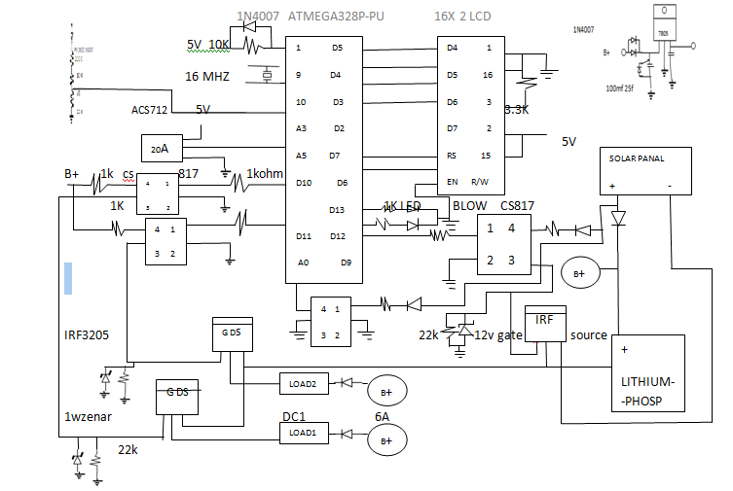
Pic circuit diagram

- MAXIMUM POWER POINT TRACKING

The use of MPPT is the extracting the concentrated power at any environmental condition. Using the MPPT technique, definitely improve the efficiency of SPV panel. Here we are using perturbation and observation MPPT technique.

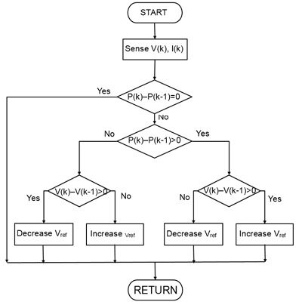
Fig 3. Flow chart of P&O MPPT
In this technique, first of all the current and voltage of SPV is sensed. The power is given by the reproduction of voltage and current of sound piezo panel. The output power is increasing due to the PV current increases. So the reference current is also increased otherwise the reference current is decreased. If the output power reduced with increasing solar panel current, the reference current is decreased by one step; otherwise the reference current is increased by one step. If the power is

increasing, the perturbation will be in the forward direction otherwise direction will be inverted. Due to this continuous process SPV panel is able to extract maximum power in any environmental condition.
- MPPT BOOST CONVERTER
Following figure shows the simulation model of the DC-DC converter. The input capacitor is compulsory to steady the input voltage due to the peak current must of exchanging power supply. Specification of inductor is very important which decided through the following equation.

(3)

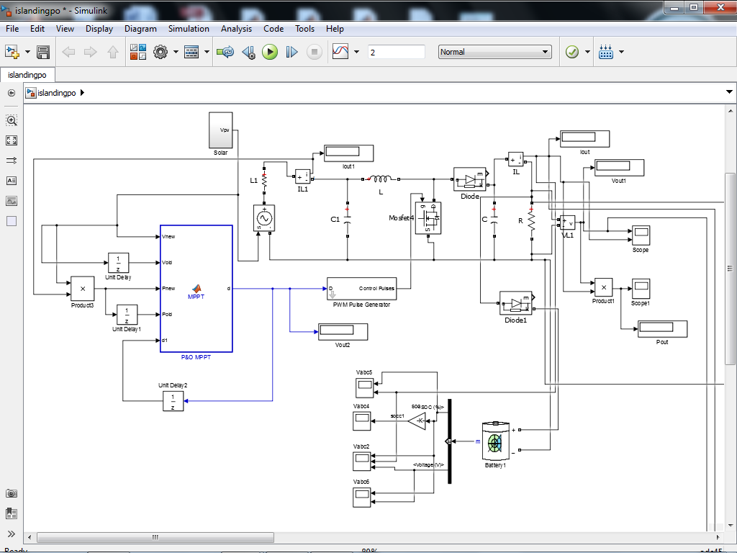

Since the type of DC/DC converter chosen for this project is the buck/boost converter, it will step the input voltage down based on the duty cycle. The preset duty cycle for the simulation is 50%, so the voltage from the input of the buck converter will be reduced by half when measure the output of the converter.
The output voltage and current of the buck/boost converter gets sampled and then calculated for power. The calculated power then gets compared to the previous maximum power, if there is one. For the comparison, if the current power is greater than the previous maximum power and the current voltage is also greater than the previous voltage, then the converter’s duty cycle increases. Likewise, if the current voltage is less than previous voltage then the duty cycle decreases. As for the case that current power is less than the previous power, and the current voltage is greater than the previous voltage, according to P&O algorithm, the duty cycle of the buck/boost converter should decrease. However, if the current voltage is less than the previous voltage, then increase the duty cycle. The process described above is in one loop of the code. Before starting the next loop, the current power is set to the previous power if it is greater than the previous power. Then a new loop of the same process which is by starting to measure the new voltage and current that is resulted from the newly set duty cycle of the buck converter. Refer to the flowchart in above for a clearer understanding [25].

OVERVIEW
There exist three basic techniques which can be used to convert DC energy into AC. Which are;
- Step-up and chop
- Chop only
(iii)Chop and transform
This AC may then be fed into the grid or can be used for stand-alone operation of 240V appliances.
- STEP UP AND CHOP TECHNIQUE

This type converts the low voltage into a high voltage first with a square-wave step-up converter and then converts the high-voltage DC into the wanted AC waveform. Advantage of this architecture: insulation between input and output, easy dimensioning of the input converter, Efficiency may be up to 95% for square-wave, slightly lower for sine-wave inverters [13,5].

- CHOP AND TRANSFORM TECHNIQUE
This type converts the low voltage DC into a low voltage AC first and then converts the low-voltage AC into the wanted AC voltage. The advantages are the low-voltage (=safe) operation, the insulation from the grid after the inverter, the ease with which it makes sine-wave which feeds into the transformer and the most important in many aspects: reliability due to the low number of semiconductors in the power path. Disadvantage is the slightly lower efficiency of the inverter, typically 92%. Also some hum can be generated by the transformer under load ,
- CHOP ONLY TECHNIQUE
This type requires the input voltage to be higher than the output voltage and converts it directly into the wanted AC waveform.as show below in figure 3.1. The advantage of this is the high efficiency of the inverter, typical 96%. The main disadvantage is the lack of insulation between the solar modules and the grid voltages. Also the input voltages always require a large number of modules [5]. This is the architecture which is designed and implemented in this paper.

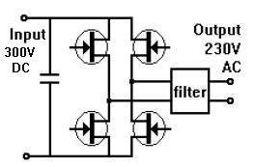

Fig 3.1 chop only inverter topology
3.2 PROJECT APPROACH
While designing an inverter can be complex, it does become easier when broken down into its component steps. The following sections detail each component within the project, as well as how each section is constructed and interacts with other blocks to result in the production of a 240V pure sine wave power inverter.
ELEMENTS OF INVERTER

STEP UP DC-DC
The DC output voltage from the battery is in relatively small amplitude compared to standard nominal single phase voltage rating for use with domestic household products or to be transferred at grid. The boosts DC-DC converter circuit will step-up the unregulated DC voltage to 340V DC regulated [5]. In this design the DC-DC boost will be developed and implemented by another project hence it will not be discussed at depth in this report.
MICROCONTROLLER
The main component of this inverter is a microcontroller as it is used to generate control signals. The theory of encoding a sine wave with a PWM signal is relatively simple. A sine wave is needed for the reference that will dictate the output, and a triangle wave of higher frequency is needed to sample the reference and actuate the switches. The process can also be done with a microcontroller and crystal oscillators as shown in fig 3.3. Since the control technique which will be used is a sinusoidal pulse width modulated PIC16F877A was chosen to generate required signal. This microcontroller is specially developed for the generation of Sinusoidal PWM (SPWM) and therefor it is programmed to generate two PWM signal and two rectangular pulse signals. Pins RC1, RC2 are output pin for sinusoidal pulse width modulation and RA1, RA2 are output pin for rectangular pulse signals. Also for safety purposes and to indicate when the inverter is ON led has been added and programed at pin RA0 to light green whenever the inverter is functioning.
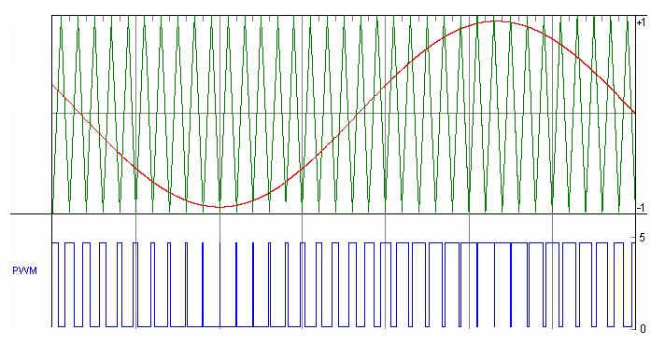

Fig 3.3 PWM generation

INTERNAL ARCHITECTURE
PIC16F72a has Harvard architecture [4]. Harvard architecture is a newer concept than von Neumann. It rose out of the need to speed up the work of a microcontroller. In Harvard architecture data bus and address bus are separate. Thus a greater flow of data is possible through the central processing unit and of course a greater speed of work. Separating a program from data memory makes it further possible for instructions not to have to be 8-bits instructions which allows for all instructions to be one word instructions. It is also typical for Harvard architecture to have fewer instructions than von-Neumann's, and to have instructions usually executed in one cycle. Microcontrollers with Harvard architecture are also called "RISC microcontrollers"[7]. Fig.3.4 presents the internal block of the PIC16F72a.
GENERATING CONTROL SIGNALS
The microcontroller is tasked with generating four control signals that are used as inputs to the Mosfet driver. They are two 50 Hz square wave and two 2-level pulse width modulated at 180 degrees out of phase. In order for the microcontroller to give this outputs it has to be programmed. The concept used is simpler and easily implement with PIC4047. A 50Hz sinusoid with unity magnitude is multiplied with the impulse train of 5000Hz so that one complete cycle of sinusoid contains 100 impulses as shown in Fig.3.3. 5000Hz PWM can be generated in such a manner that starting position of pulse should be same as that of impulse and duty cycle of the pulse must be equal to the product of unit impulse and value of sine at that instant as shown in Fig. 2.
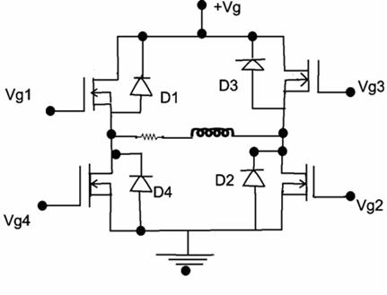
H-BRIDGE

Fig 3.7 Single phase h-bridge
An H-Bridge or full bridge converter is a switching configuration composed of four switches in this case MOSFETs in an arrangement that resembles an H [10]. By controlling which switches are closed at any given moment, the voltage across the load can be either positive, negative, or zero. As shown in fig 3.7 a solid state h-bridge is built using four switches. When switch S1 and S2 are closed (according to fig 3.7) and switches S3 and S4 are open a positive voltage will be applied across the load. By closing S3 and S4 switches and opening S1 and S2 switches a reverse voltage will be applied to the load. Using nomenclature above switches S1 and S4 should never be closed at the same time as this will cause a shot circuit on between the power supply and ground, potentially damaging the devices or draining the power supply. The same applies to switches S2 and S3. This condition is known as shoot-through. The table below outlines the positions. Note that shoot-through switch positions are omitted.The switches used to implement an H-Bridge can be mechanical or built from solid state transistors. Selection of the proper switches varies greatly.

S1 | S2 | S3 | S4 | Vo
ON | ON | OFF | OFF | +Ve
OFF | OFF | ON | ON | -Ve
ON | OFF | ON | OFF | ZERO
OFF | ON | OFF | ON | ZERO

Table 1.

IGBTs vs. Power MOSFETs

While designing this circuit, a choice had to be made between the two main types of switches used in power electronics. One is the power MOSFET which is much like a standard MOSFET but designed to handle relatively large voltages and currents. The other is the insulated gate bipolar transistor (IGBT) [5]. Each has its advantages, and there is a high degree of overlap in the specifications of the two.

IGBTs tend to be used in very high voltage applications, nearly always above 200V, and generally above 600W. They do not have the high frequency switching capability of MOSFETs, and tend to be used at frequencies lower than 29 kHz. They can handle high currents, are able to output greater than 5kW, and have very good thermal operating ability, being able to operate properly above 100 Celsius. One of the major disadvantages of IGBTs is their unavoidable current tail when they turn off. Essentially, when the IGBT turns off, the current of the gate transistor cannot dissipate immediately, which causes a loss of power each time this occurs. This tail is due to the very design of the IGBT and cannot be remedied. IGBTs also have no body diode, which can be good or bad depending on the application. IGBTs tend to be used in high power applications, such as uninterruptible power supplies of power higher than 5kW, welding, or low power lighting [10].
Power MOSFETS have a much higher switching frequency capability than do IGBTs, and can be switched at frequencies higher than 200 kHz. They do not have as much capability for high voltage and high current applications, and tend to be used at voltages lower than 250V and less than 500W. MOSFETs do not have current tail power losses, which makes them more efficient than IGBTs. Both MOSFETs and IGBTs have power losses due to the ramp up and ramp down of the voltage when turning on and off (dV/dt losses). Unlike IGBTs, MOSFETs have body diode.
Generally, IGBTs are the sure bet for high voltage, low frequency (>1000V, <20 kHz) uses and MOSFETs are ideal for low voltage, high frequency applications (<250V, >200 kHz). In between these two extremes is a large grey area. In this area, other considerations such as power, percent duty cycle, availability and cost tend to be the deciding factors. Since this project is about design of a 600W inverter, with a 340VDC bus (ideally), and a switching frequency of 5 kHz MOSFET is the ideal choice, in spite of MOSFET switches having high ON state resistance and conduction losses [5]. Also MOSFET being a voltage controlled device, it can be driven directly from CMOS or TTL logic and the same gate signal can be applied to diagonally opposite switches since the gate drive current required is very low [5]. If our system was a larger, commercial application with a high power output, IGBTs would be the choice.

ENHANCED N-CHANNEL VS ENHANCED P-CHANNEL MOSFETS
The use of P-Channel MOSFETs on the high side and N-Channel MOSFETs on the low side is easier, but using all N-Channel MOSFETs and a FET driver, lower “on” resistance can be obtained resulting in reduced power loss. This requires a more complex circuit since the gate of the high side Mosfet must be driven positive with respect to Vs bus voltage to turn on the Mosfet [9].

MOSFETs CHARACTERISTIC
In this project enhanced n-channel Mosfet was chosen for both high side and low side switches of the h-bridge. For the Mosfet to carry drain current Id (on state) a channel between the drain and source must be created. This occurs when drain to source Vgs voltage exceeds the device threshold (Vgs>Vth). Once the channel is induced the Mosfet can operate in either triode region (drain current proportional to channel resistance) or the saturation region
(constant drain current). The gate to drain voltage Vgs determines whether the induced channel enters pitch-off or remains in triode region. When used as a switching device only triode and cut-off region are utilized.

The device will operate at cut-off (off state) when gate to source voltage Vgs is less than threshold voltage Vth (Vgs<Vth) [15]. Fig 3.8a shows schematic symbol, fig 3.8b shows its drain characteristic and fig3.8c shows drain current flows only when Vgs exceeds threshold voltage.
1. | Triode region; | Vds<Vgs-Vth
2. | Saturation region; | Vds>Vgs-Vth
3. | Cut-off region; | Vgs<Vth
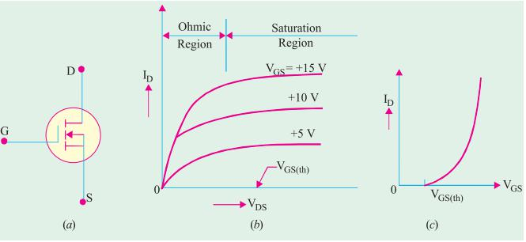

Figure 3.8 N channel Mosfet characteristic

MOSFET DRIVER
As stated in the previous section, it is beneficial to use N-channel MOSFETs as the high side switches as well as the low side switches because they have a lower ‘ON’ resistance and therefore less power loss. However, to do so, the drain of the high side device is connected to 340V DC power which is to be inverted into the 240V AC power. This is a problem because the 340V is the highest voltage in the system and in order for the switch to be turned on the voltage at the gate terminal must be 10V higher than the drain terminal voltage [15, 16]. Therefore, to drive MOSFETs in the H-Bridge MOSFET driver IC is used with a bootstrap capacitor specifically designed for driving a half-bridge. After considering various IC options, the ideal choice was the IR2110, which is rated at 600V, with a gate driving current of 2A and a gate driving voltage of 10-20V. The turn on and turn off times are 120ns and 94ns respectively [17].

The MOSFET driver operates from a signal input given from the microcontroller and takes its power from the battery voltage supply that the system uses. The driver is capable of operating both the high side and low side devices, but in order to get the extra 10V for the high side device, an external bootstrap capacitor is charged through a diode from the 18V power supply when the device is off. Because the power for the driver is supplied from the low voltage source, the power consumed to drive the gate is small. When the driver is given the signal to turn on the high side device, the gate of the MOSFET has an extra boost in charge from the bootstrap capacitor, surpassing the needed 10V to activate the device and turning the switch on [18].
The controller section to switch the system in the inverter/battery mode.In this mode the controller begins generating the required PWMs via its pin#13 (ccp out), however the PWM generation rate is implemented only after the controller confirms the logic level at pin#16 (INV/UPS switch). If a high logic is detected at this pin (INV mode) the controller initiates a fully modulated duty cycle which is around 70%, and in case of a low logic at the indicated pinout of the IC, then the controller may be prompted to generate burst of PWMs ranging from 1% to 70% at a rate of 250mS period, which is termed as soft delay output while in the UPS mode. The controller simultaneously with the PWMs also generates a "channel select" logic through pin#13 of the PIC which is further applied to pin#8 of the IC CD4081.Throughout initial time period of the pulse (i.e 10ms) the pin12 of the PWM controller is rendered high such that the PWM can be obtained from pin10 of CD4081 exclusively

and after 10mS, pin14 of controller is logic high and the PWM is accessible from pin11 of CD4081, as a result using this method a pair of anti-phased PWM becomes accessible to switch on the MOSFETS. Aside from that a high logic (5V) becomes accessible from pin11 of the PWM controller, this pin turns high each time inverter is ON and ends up being low whenever inverter is OFF. This high logic is applied to pin10 of each the MOSFET drivers U1 and U2, (HI pin) to activate the high side MOSFETs of the two the mosfet banks.For upgrading the proposed Sinewave UPS using PIC16F72, the following data may be used and implemented appropriately.

ATmega328 Microcontroller
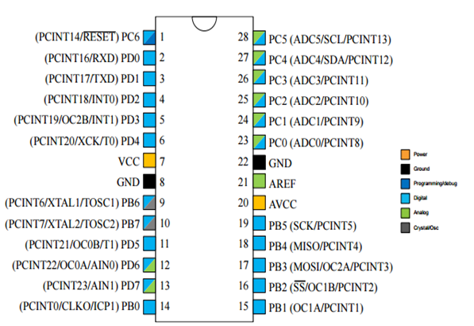
ATmega328 is an 8-bit high performance microcontroller of Atmel’s Mega AVR family with low power consumption. ATmega16 is based on enhanced RISC architecture with 131 power full instructions most of the instructions execute in one machine cycle. ATmega16 can work on maximum frequency of 16MHz. ATmega328 has 16KB programmable flash memory, static RAM of 1KB and EEPROM of 512byte. The endurance cycle of flash memory and EEPROM is 10000 and 100000 respectively. ATmega16 is a 40 pin microcontroller there are 28 I/O lines which are divided into four 8-bit ports designated as PORTA, PORTB, PORTC. ATmega328 has various in-built peripherals like USART, ADC, Analog comparator, SPI, JTAG etc. Each input output pin has an alternative task related to inbuilt peripherals. AVR microcontroller 4times faster than 8051 microcontroller. It based on RISC architecture with PWM channel and inbuilt ADC. Memory size is large as compare to 8051 microcontroller and consumes less power Due to this specialty we use ATmega 328 microcontroller.

Conclusion

The project has been successfully completed up to 50%, covering the design and theoretical aspects of the system. The study of solar and sound energy, along with the implementation of the MPPT technique using the Perturb and Observe algorithm, has been clearly understood. Key components such as the microcontroller, DC-DC converter, battery, and inverter have been selected and their working principles have been defined.
The system design, block diagram, and overall methodology are now finalized, providing a strong base for further development. The next phase of the project will focus on hardware implementation, programming, testing, and final integration.
Overall, the project is progressing in the right direction, and the remaining work will help in achieving a complete and efficient working model.

References
[1] Huynh D.C & et. all. Maximum power point tracking of solar photovoltaic panels using advanced perturbation and observation algorithm. IEEE June 2013.

[2] Grzesaik. W. MPPT Solar Charge Controller for High Voltage Thin Film PV Modules. IEEE May 2006.

[3] Petchjatuporn. P and et. all. A Solar-powered Battery Charger with Neural Network Maximum Power Point Tracking Implemented on a Low-Cost PIC-microcontroller. IEEE Nov 2005.

[4] Longxi. Chang & et. all. A fully integrated solar charger controller with input MPPT regulation protection for 10V to 28V solar-powered panel. IEEE June 2013.
[5] Boco, M. A. (2022).
Sound Energy Harvesting and Converting Electricity (SEHCE).
Annals of Mathematics and Physics, 5, 146–149.
[6] Cao, Y., Sha, A., Liu, Z., Li, J., & Jiang, W. (2021).
Energy output of piezoelectric transducers and pavements under simulated traffic load.
Journal of Cleaner Production, 279, 123508.
[7]Chen, J., Qiu, Q., Han, Y., & Lau, D. (2019).
Piezoelectric materials for sustainable building structures: Fundamentals and applications.
Renewable and Sustainable Energy Reviews, 101, 14–25.
[8]Choi, J., Jung, I., & Kang, C.-Y. (2019).
A brief review of sound energy harvesting Nano Energy, 56, 169–183.
[9] Chrysochoidis-Antsos, N., Amoros, A. V., Van Bussel, G. J., Mertens, S. M., & Van Wijk, A. J. (2020).
Wind resource characteristics and energy yield for micro wind turbines integrated on noise barriers – An experimental study.
Journal of Wind Engineering and Industrial Aerodynamics, 203, 104206.
[10] Chu, L., Fwa, T., & Tan, K. (2017).
Evaluation of wearing course mix designs on sound absorption improvement of porous asphalt pavement.
Construction and Building Materials, 141, 402–409.
[11] Covaciu, D., Florea, D., & Timar, J. (2015).
Estimation of the noise level produced by road traffic in roundabouts.
Applied Acoustics, 98, 43–51.
[12]Cui, N., Gu, L., Liu, J., Bai, S., Qiu, J., Fu, J., Kou, X., Liu, H., Qin, Y., & Wang, Z. L. (2015a).
High performance sound driven triboelectric nanogenerator for harvesting noise energy.
Nano Energy, 15, 321–328.
[13]Cui, Y., Zhang, Q., Yao, M., Dong, W., & Gao, S. (2015b).
Vibration piezoelectric energy harvester with multi-beam.
AIP Advances, 5, 041332.

[14]Dong, J., Meng, W., Liu, Y., & Ti, J. (2021).
A framework of pavement management system based on IoT and big data.
Advanced Engineering Informatics, 47, 101226.
[15]Estévez-Mauriz, L., &Forssén, J. (2018).
Dynamic traffic noise assessment tool: A comparative study between a roundabout and a signalised intersection.
Applied Acoustics, 130, 71–86.

